**DB TESTING:**

**Dependencies**: **DB** **driver** based on the DB---oracle, pos

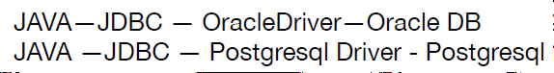

**Connection connection= DriverManager.getConnection(url,username,password***)*

**Statement** **statement**= connection.createStatement

*(***ResultSet**.*TYPE_SCROLL_INSENSITIVE*,**ResultSet**.*CONCUR_READ_ONLY)*;

**ResultSet resultSet= statement.executeQuery*(*querry***)*;

**ResultSetMetaData** resultSetMetaData= resultSet.getMetaData*()*;

resultSet.**close**(); statement.**close**(); connection.**close**();

**ResultSetMetaData**

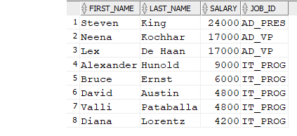

Map1

Map2

Map3

**ResultSet**

Map4

.

.

.

resultSet.**last***()*; resultSetMetaData.**getColumnName**(i)  
resultSet.**first***()*; resultSetMetaData.**getColumnCount**();  
resultSet.**isLast***()*;

resultSet.**isFirst***()*;  
resultSet.**next***()*;  
resultSet.**afterLast***()*;  
resultSet.**isAfterLast***()*;

resultset.**getRow()**